**Integrated Analysis - Decision Tree and K-means Clustering using Tableau & R**

**Data Pre-processing**

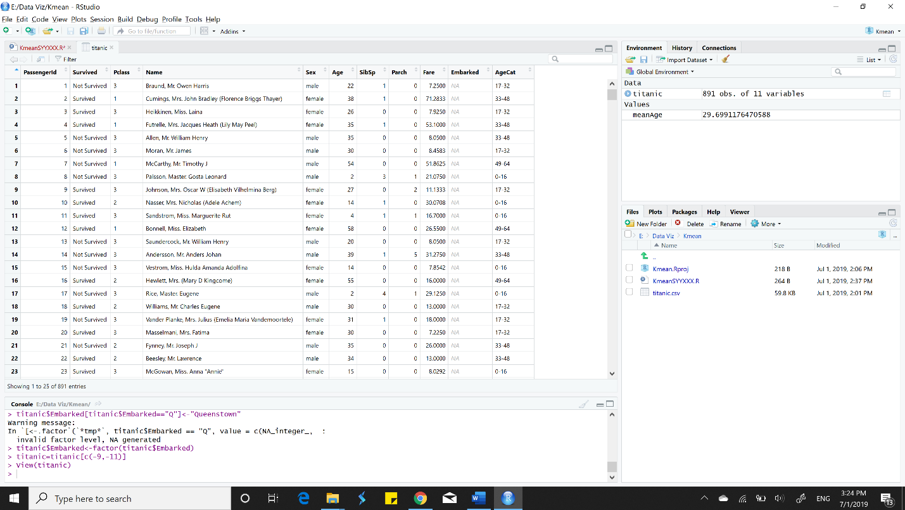

**Decision Tree**

Decision_tree_plot

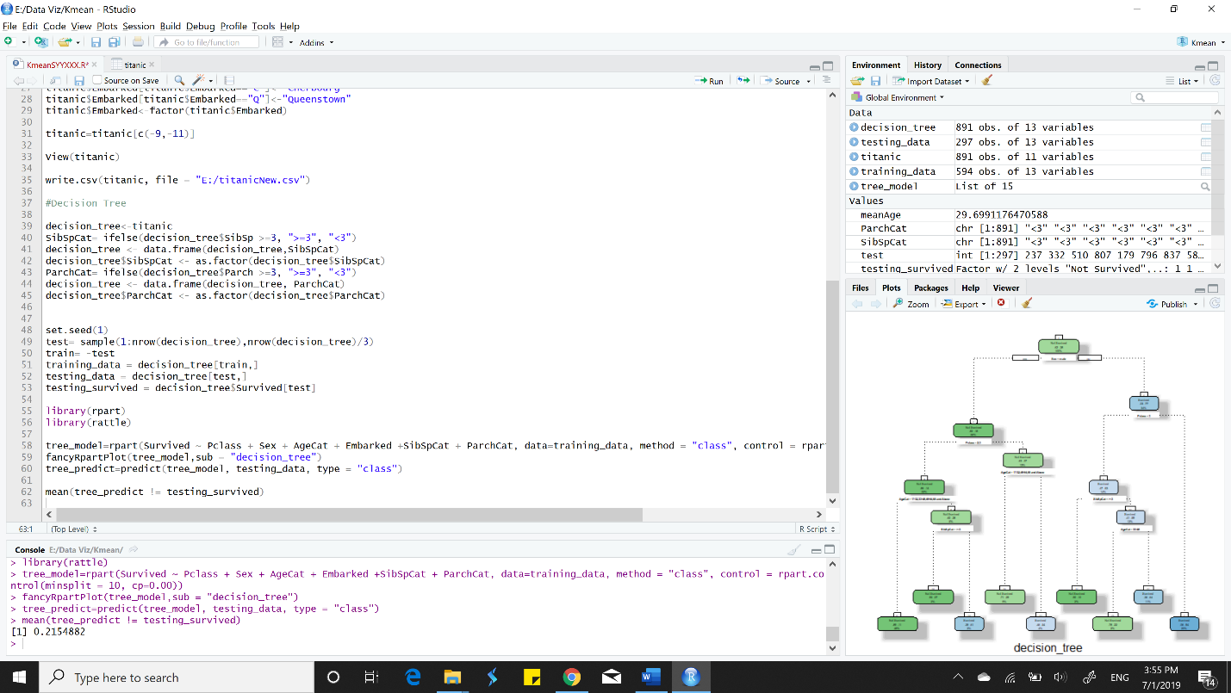

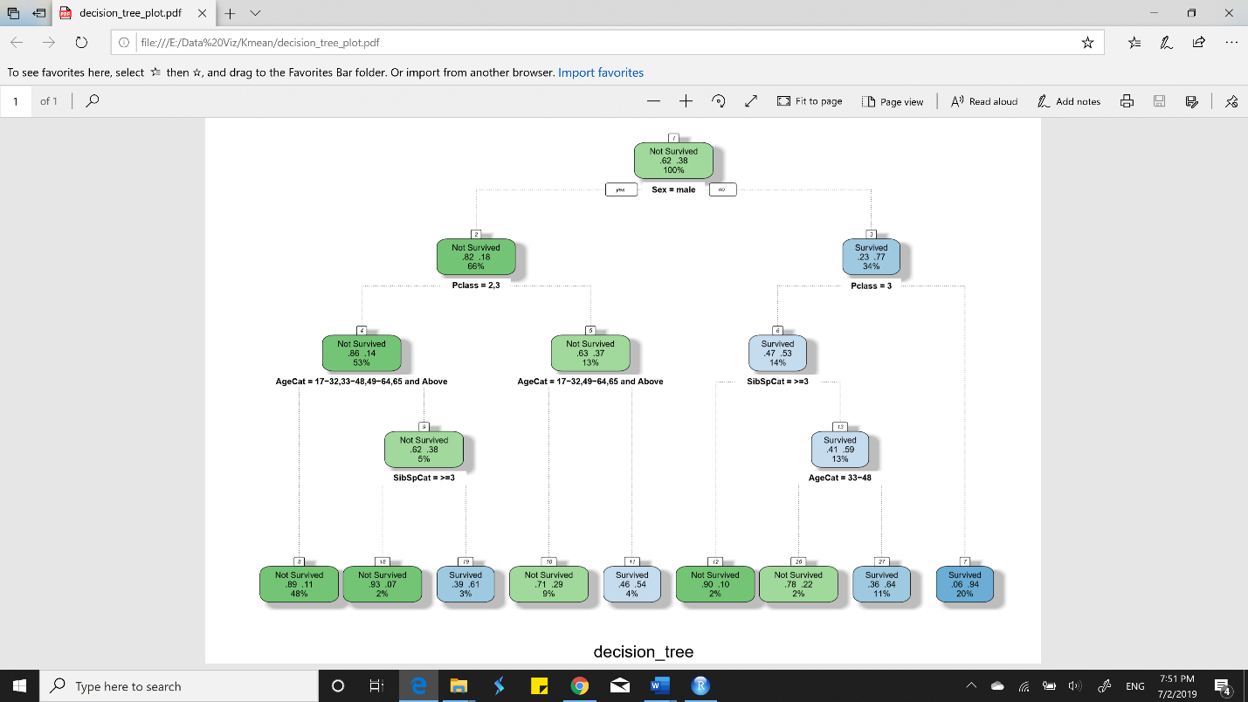

**K-means Clustering**

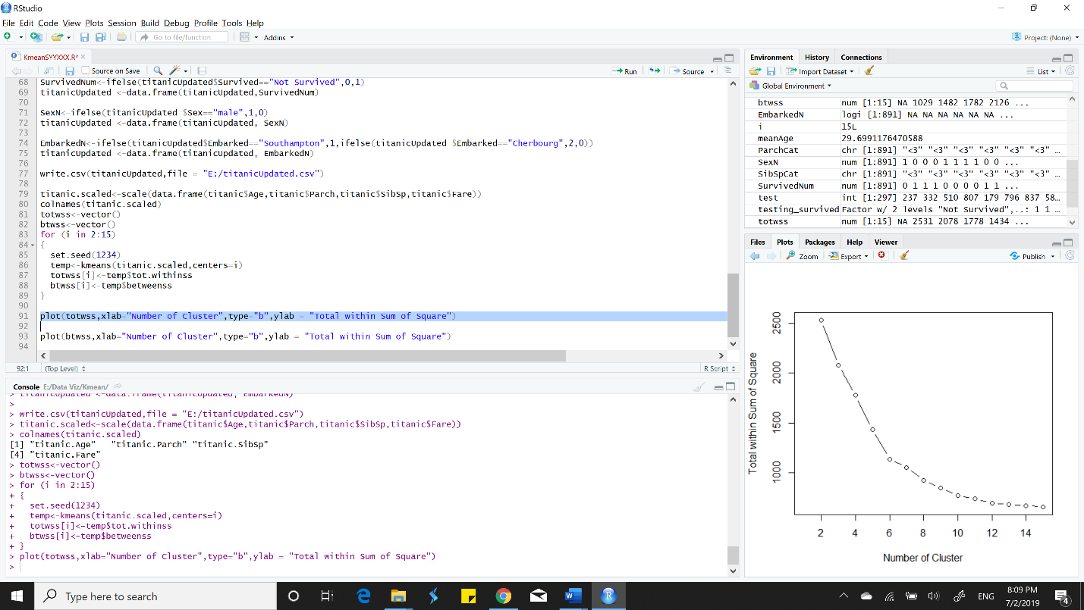

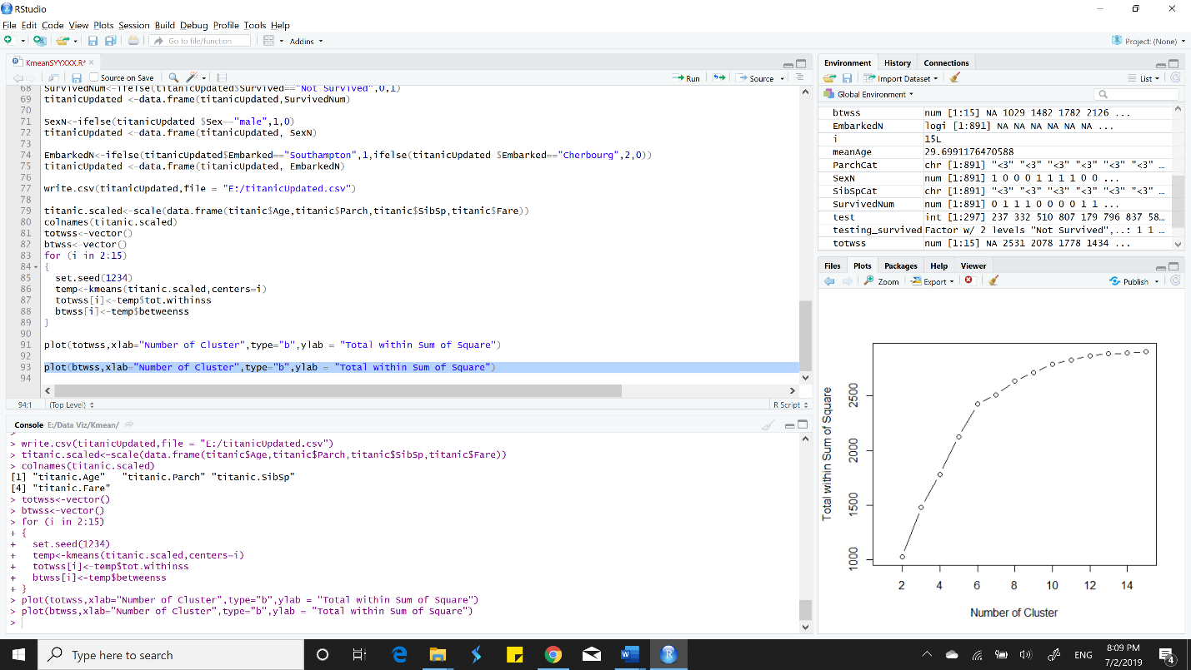

**Tableau/R-integration**

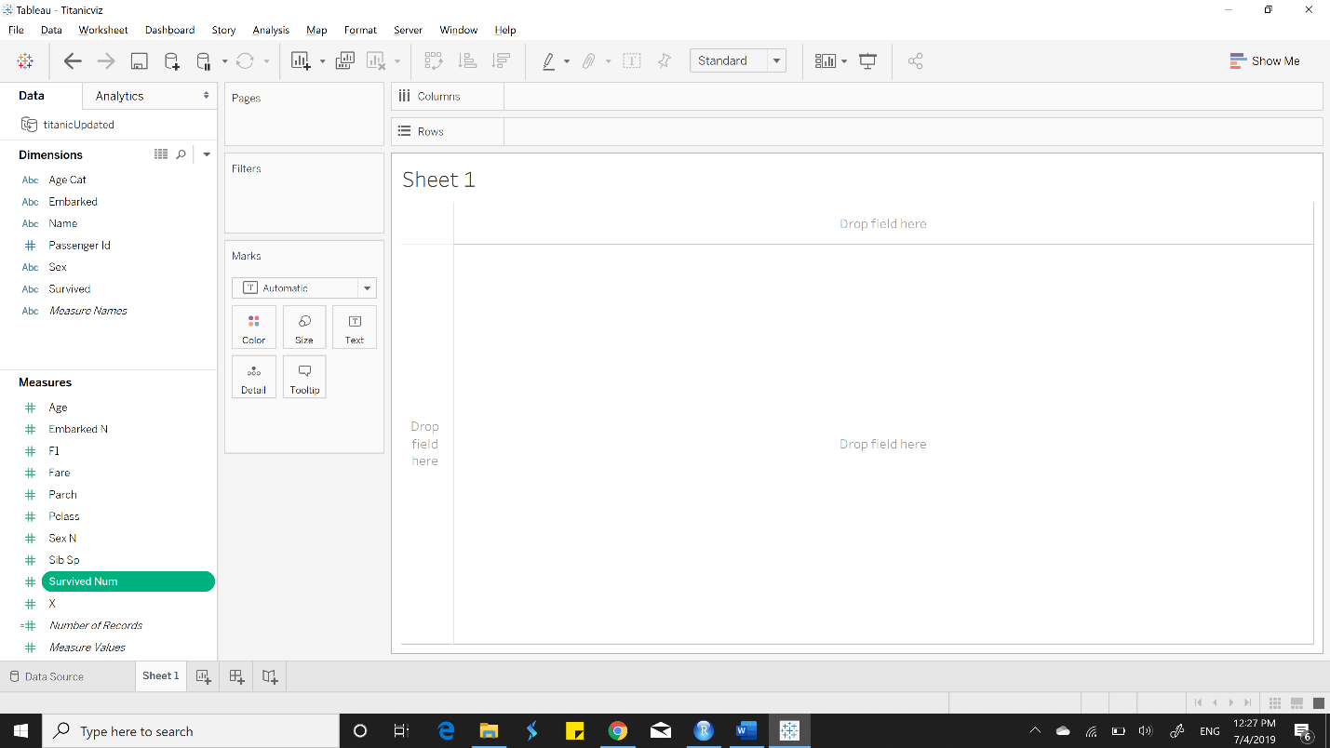

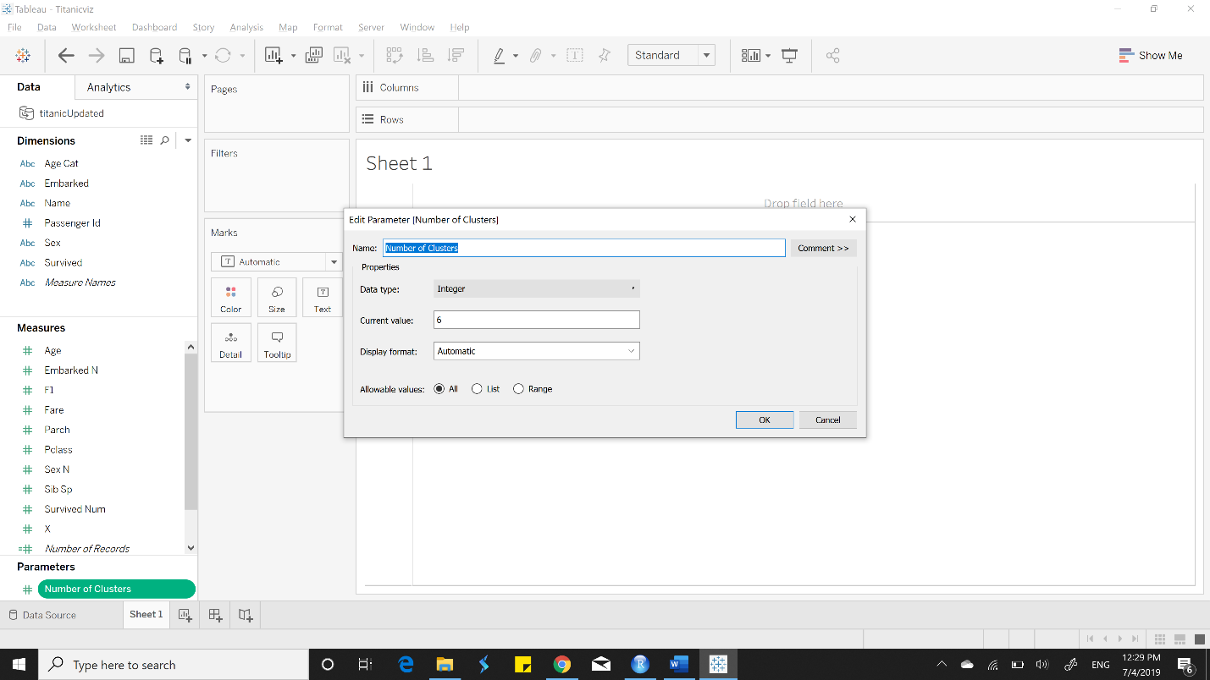

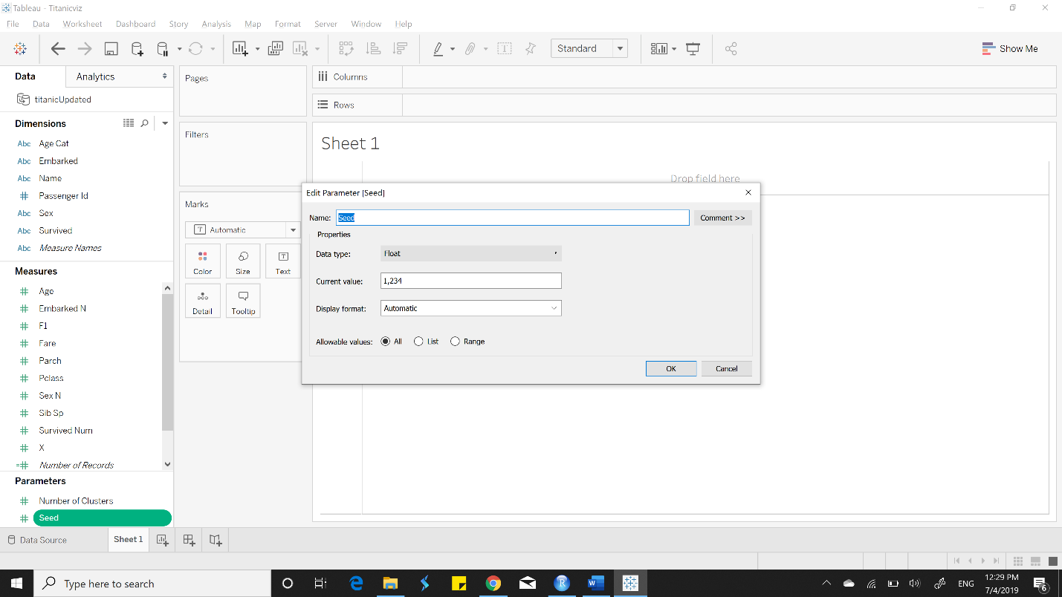

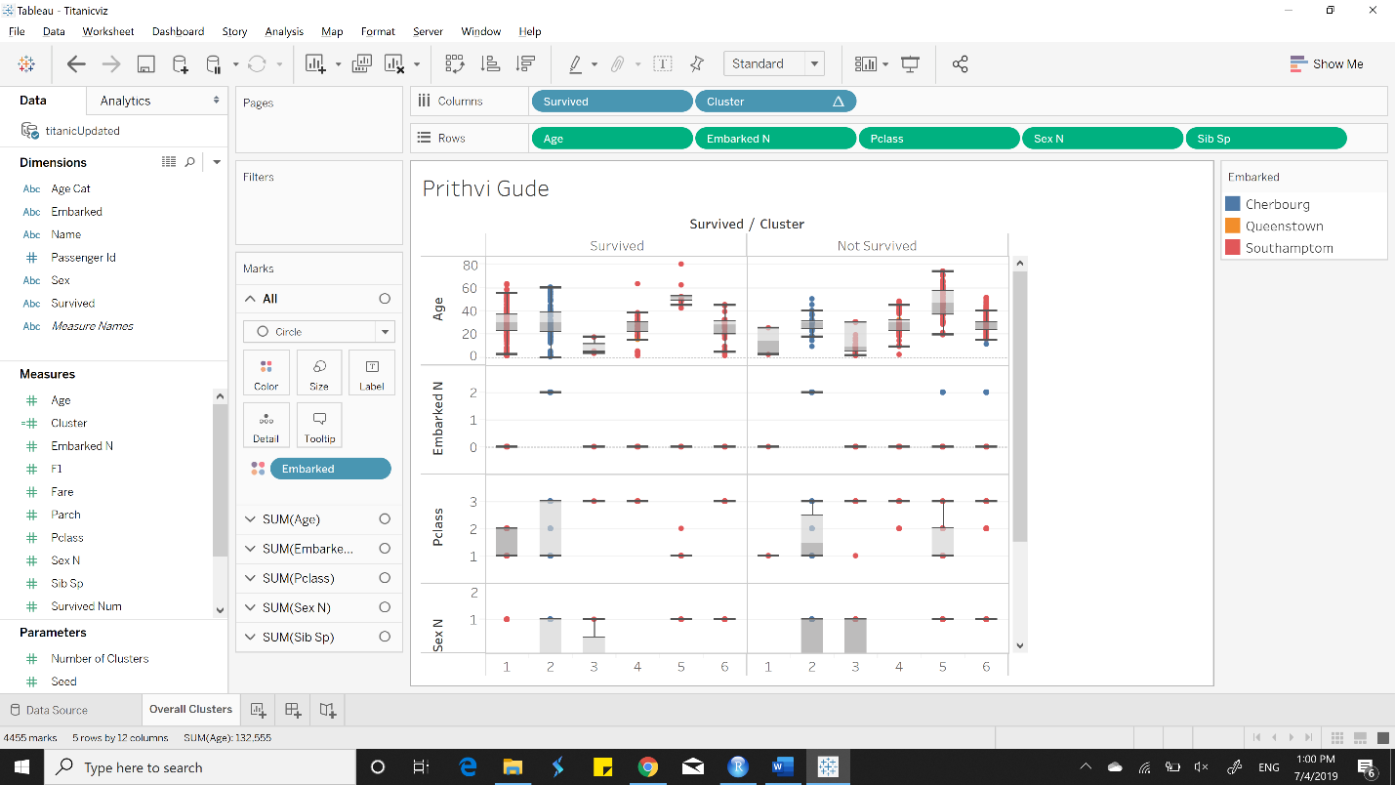

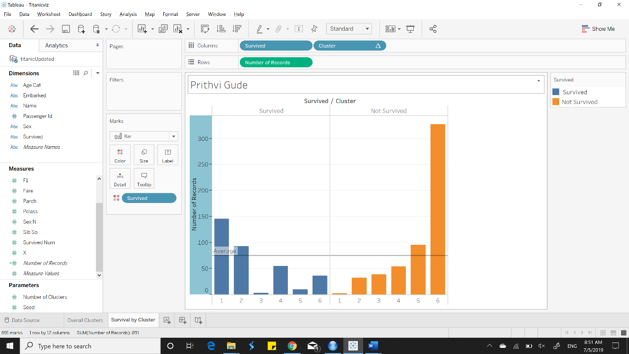

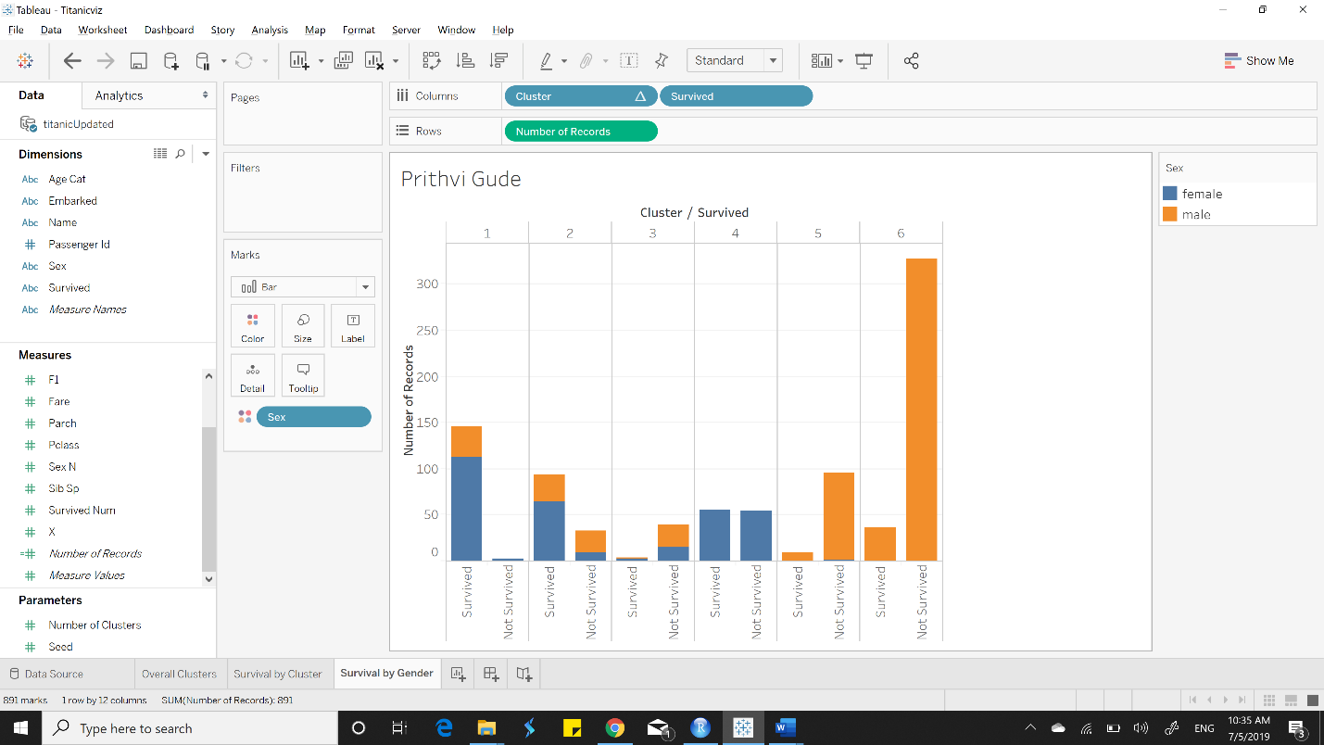

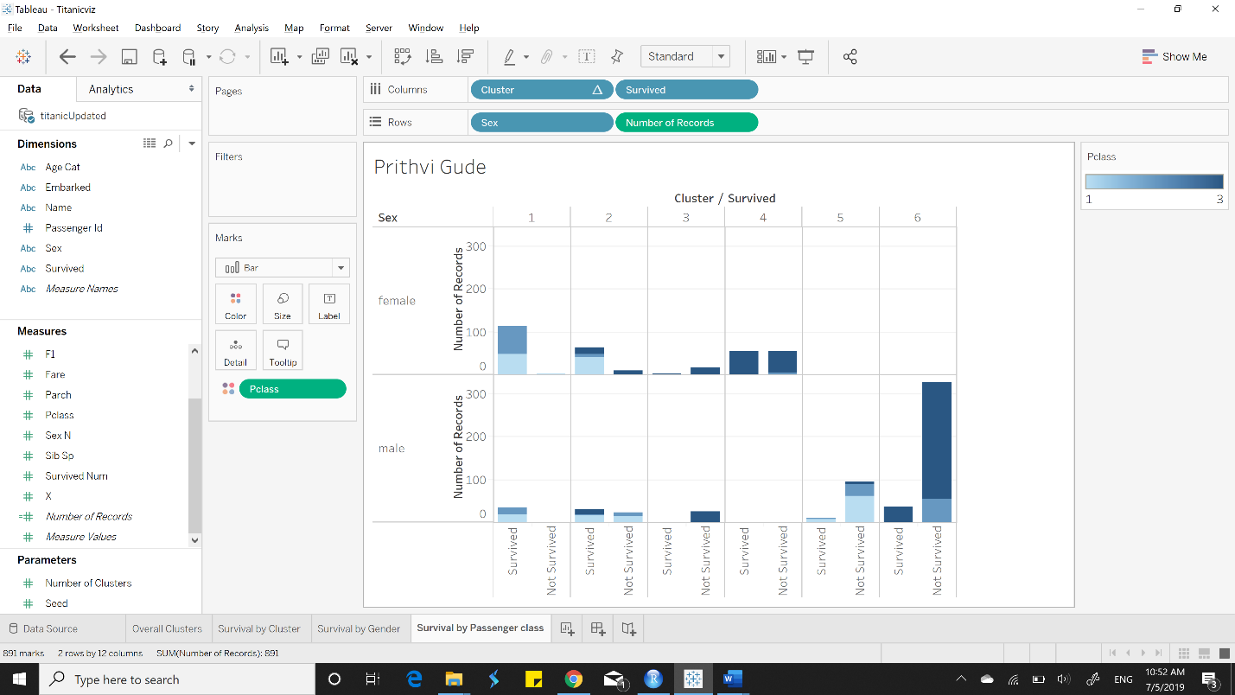

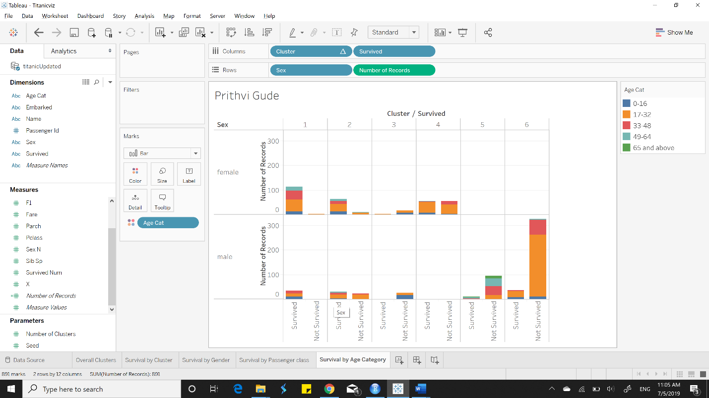

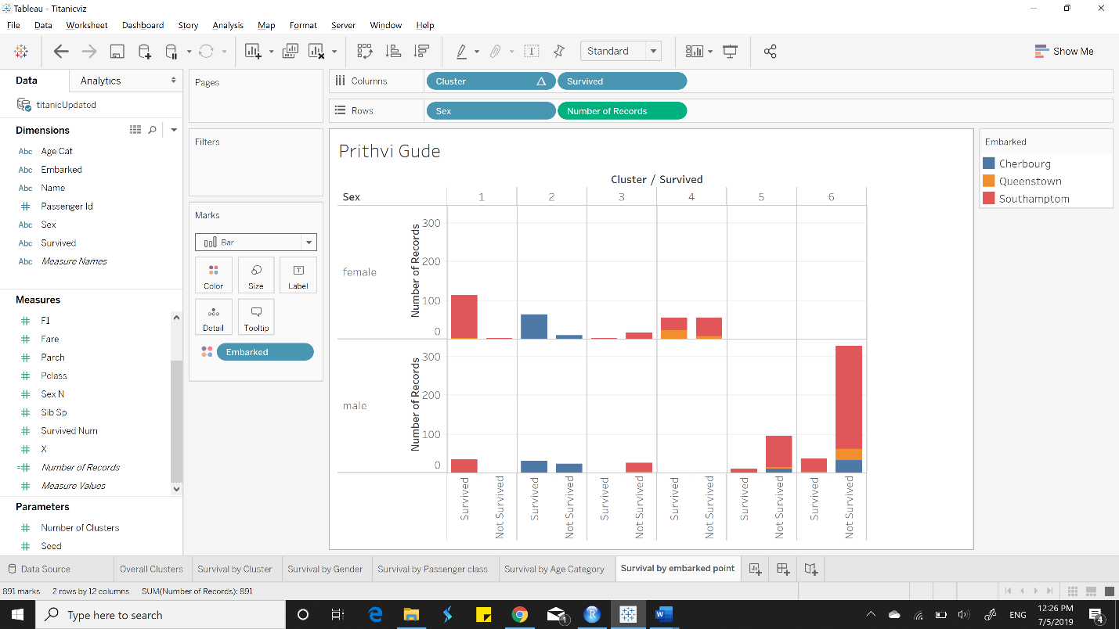

|  |  |  |
| --- | --- | --- |
|  | Cluster 1 | Cluster 2 |
| Ideal Gender | Female | Female |
| Ideal Passenger Class | 2 | 1 |
| Ideal Age Category | 17-32 | 17-32 |
| Ideal Embarked point | Southampton | Cherbourg |
| Ideal number of siblings | 0 | 0 |

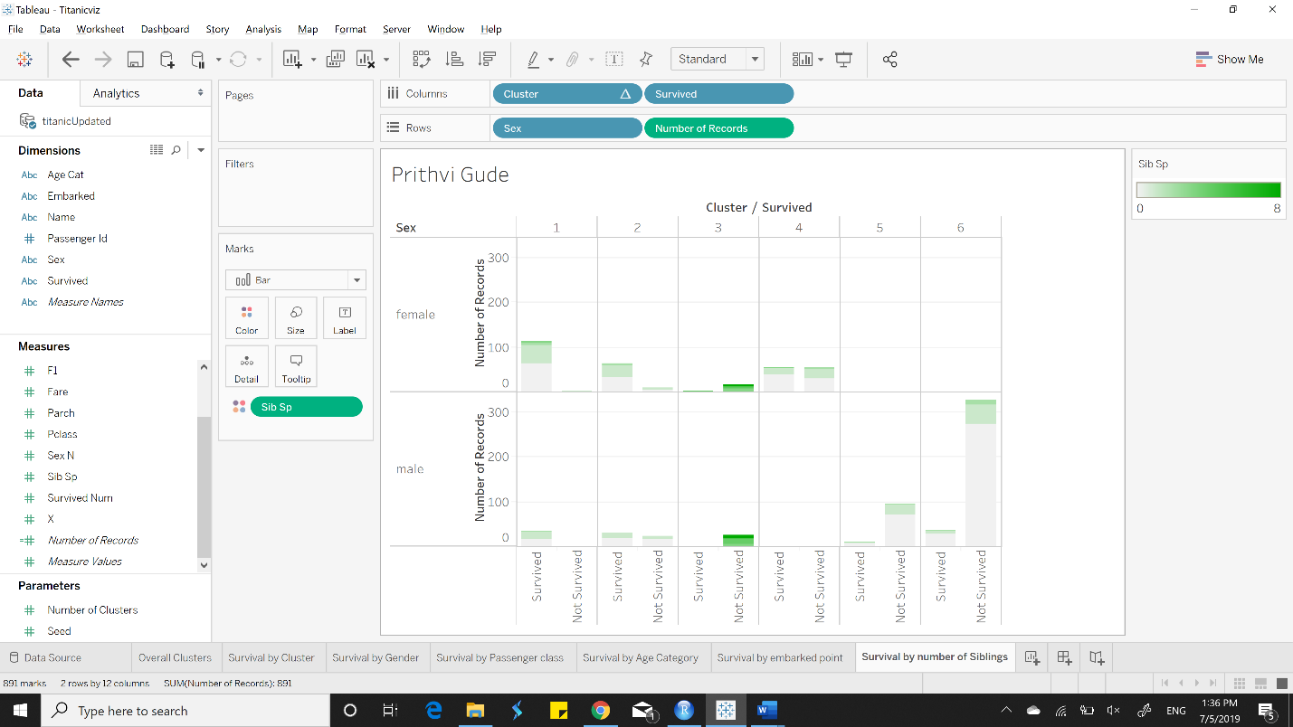

**Summary**

Cluster 1 passengers should be female between the age is 17-32 from Class 2 who embarked on Southampton and has zero siblings to have the highest chance of survival.

Cluster 2 passengers on the other hand should be female between the ages of 17-32 from Class 1 who embarked on Cherbourg and has zero siblings to have the highest chances of survival.